GoalQuest
Employee Workflow
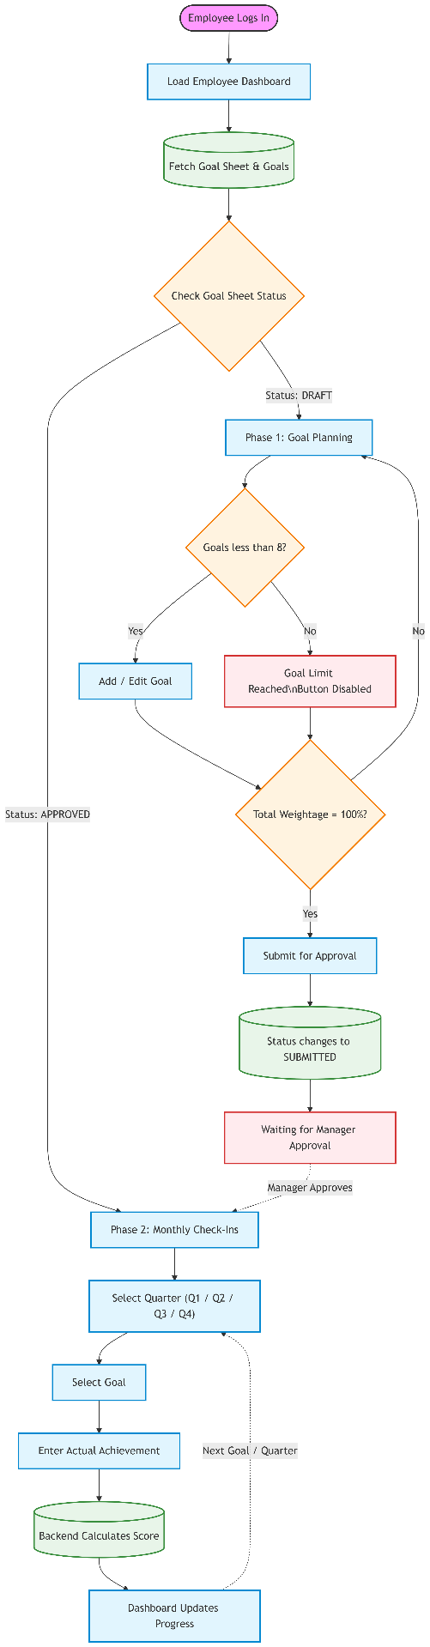
Employee Workflow
The Employee module in the GoalQuest Performance Management System enables employees to create performance goals, submit them for managerial approval, and periodically update their progress throughout the performance cycle.
The workflow is implemented through the Employee Dashboard, which serves as the employee's primary interface for goal planning and performance tracking.

1. Initialization and Dashboard Loading
The workflow begins when an employee successfully logs into the GoalQuest portal.
After authentication, the employee is redirected to the My Performance Portal (Employee Dashboard).
Automatic Data Retrieval
When the dashboard loads, the application automatically retrieves:
- The employee's active Goal Sheet.
- All goals associated with the active Goal Sheet.
- Current Goal Sheet status.
This information is displayed to allow the employee to continue working on their performance cycle.

2. Phase 1 – Goal Planning (Draft Status)
At the beginning of a performance cycle, the Goal Sheet is created with the status:
DRAFT
During this stage, the employee uses the Goal Planning section to define individual performance objectives.
Adding Performance Goals
The employee selects Add Goal and enters the following information for each goal:
- Goal Title
- Unit of Measure (UoM)
- Target Value
- Weightage (%)
Each goal represents a measurable objective that contributes toward the employee's overall performance evaluation.

System Constraints
The application enforces several validation rules while goals are being created.
Maximum Number of Goals
- An employee can create a maximum of 8 goals.
- Once eight goals have been added, the Add Goal button is automatically disabled.
This ensures that every Goal Sheet remains within the organization's defined performance framework.
Weightage Validation
As goals are added or modified, the system continuously calculates the cumulative goal weightage.
The employee may distribute the weightage across goals in any combination, provided that:
Total Goal Weightage = 100%
If the cumulative weightage is not exactly 100%, the Goal Sheet cannot be submitted for approval.

Submission for Manager Approval
Once all validation rules are satisfied:
- Total Weightage = 100%
- Goals have been completed
the Submit for Approval button becomes available.
Upon submission:
- The Goal Sheet status changes from DRAFT to SUBMITTED.
- Goal editing is disabled.
- The Goal Sheet is forwarded to the reporting manager for review and approval.

3. Phase 2 – Monthly / Quarterly Check-Ins
After managerial review, the Goal Sheet status changes to:
APPROVED
Approval unlocks the Monthly / Quarterly Check-Ins section of the Employee Dashboard.
This phase allows employees to periodically record their progress against approved goals.

Quarter Selection
The employee selects the active reporting period from:
- Q1
- Q2
- Q3
- Q4
The selected quarter determines where the progress entry will be recorded.

Goal Progress Tracking
The dashboard displays all approved goals associated with the employee.
For each goal, the employee can select Update to open the Check-In form.
The employee records:
- Actual Achievement
- Current progress for the selected quarter
For example:
- Target: 50
- Actual Achievement: 45

Automatic Performance Scoring
After the employee submits the check-in, the backend automatically evaluates performance.
The achieved value is compared with the predefined target using the goal's configured measurement type.
Supported scoring methods include:
- MAX
- MIN
- TIMELINE
- ZERO
Based on the selected scoring method, the backend calculates a normalized performance score ranging from 0.0 to 1.0.
The calculated score and achievement details are then stored as the official check-in record for the selected quarter.

4. Employee Performance Lifecycle
The complete employee workflow follows the sequence below:
- Employee logs into the GoalQuest portal.
- Employee Dashboard automatically loads the active Goal Sheet and associated goals.
- During the DRAFT phase, the employee creates performance goals by specifying the goal title, unit of measure, target, and weightage.
- The system enforces a maximum of 8 goals and requires the cumulative goal weightage to equal 100%.
- Once all validation rules are satisfied, the employee submits the Goal Sheet for managerial approval.
- The Goal Sheet status changes to SUBMITTED, preventing further modifications.
- After manager approval, the Goal Sheet status changes to APPROVED.
- The employee performs monthly or quarterly check-ins by selecting the active quarter and updating progress for each approved goal.
- The backend automatically calculates the performance score based on the configured measurement type and stores the results for performance evaluation.
This structured workflow ensures that employee objectives are properly planned, reviewed, approved, and continuously monitored throughout the performance cycle.

Manager Workflow
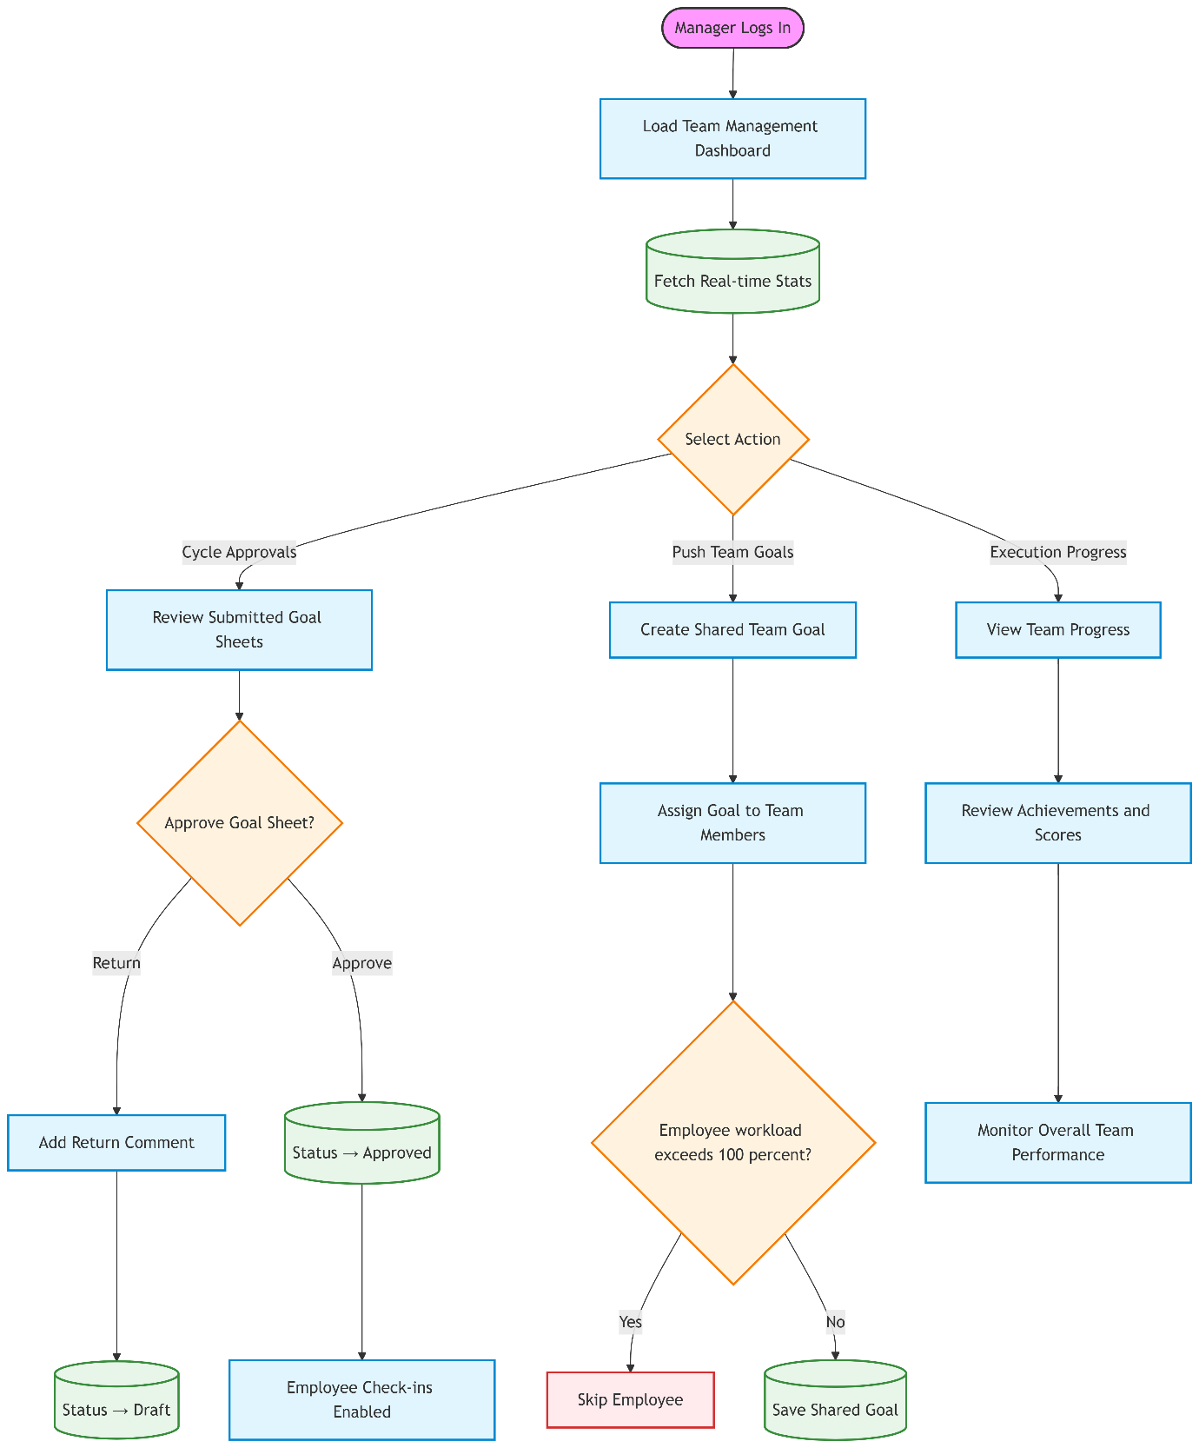
Manager Workflow
The Manager module in the GoalQuest Performance Management System enables managers to review employee goals, approve or return goal sheets, assign organizational objectives, and monitor team performance throughout the performance cycle.
The workflow is implemented through the Team Management Dashboard, which provides a centralized interface for managing direct reports and tracking goal execution.

1. Initialization and Dashboard Overview
The workflow begins when a manager successfully logs into the GoalQuest portal.
After authentication, the manager is redirected to the Team Management Dashboard.
Automatic Dashboard Statistics
Upon loading, the dashboard automatically retrieves summary information through the getManagerStats() API.
The dashboard displays key performance indicators, including:
- Total number of Direct Reports.
- Number of Pending Goal Sheet Approvals.
- Number of Unread Employee Check-Ins.
These real-time statistics provide the manager with an overview of current team activities and pending actions.

2. Phase 1 – Goal Sheet Review and Approval
During the goal planning stage, managers review the Goal Sheets submitted by their direct reports.
This functionality is available through the Cycle Approvals section of the dashboard.
Reviewing Submitted Goal Sheets
The manager views all employees whose Goal Sheets are currently in the:
SUBMITTED
status.
For each Goal Sheet, the manager reviews:
- Employee goals.
- Target values.
- Units of Measure (UoM).
- Goal weightages.
- Overall goal distribution.

Approval Decisions
After reviewing the submitted goals, the manager can perform one of the following actions.
Approve Goal Sheet
If the goals satisfy organizational expectations, the manager approves the Goal Sheet.
This action:
- Changes the Goal Sheet status from SUBMITTED to APPROVED.
- Locks the employee's goals to prevent further modification.
- Enables the employee to begin monthly or quarterly performance check-ins.
Return Goal Sheet
If revisions are required, the manager may return the Goal Sheet.
This action:
- Changes the Goal Sheet status back to DRAFT.
- Records a return comment explaining the required changes.
- Allows the employee to modify the goals and resubmit them for approval.

3. Phase 2 – Goal Distribution (Push Team Goals)
Managers can assign organizational objectives to their entire team to ensure alignment with business priorities.
This functionality is available through the Push Team Goals section.
Creating Team Goals
The manager creates a shared organizational goal by specifying details such as:
- Goal Title
- Unit of Measure (UoM)
- Target Value
- Weightage
Example:
Achieve Q3 Sales Quota

Intelligent Goal Distribution
When the manager pushes the goal to team members, the backend evaluates each employee individually.
For every employee, the system calculates:
- Current cumulative goal weightage.
- Remaining available weightage.
The shared goal is typically assigned with a default weightage of 10%.

Workload Protection
Before assigning the shared goal, the system verifies that adding the new goal will not cause the employee's total goal weightage to exceed 100%.
The assignment logic is as follows:
- Total Weightage ≤ 100%
  - Goal is automatically added to the employee's Goal Sheet.
- Total Weightage > 100%
  - Goal assignment is skipped.
  - Existing employee goals remain unchanged.
This mechanism prevents employee over-allocation while maintaining organizational alignment.

4. Phase 3 – Execution and Performance Tracking
After Goal Sheets have been approved, employees begin submitting periodic performance updates.
Managers monitor this activity through the Execution Progress section of the dashboard.
Team Performance Monitoring
The manager can view performance updates submitted by all direct reports for the active reporting period.
The dashboard displays:
- Approved goals.
- Quarterly check-ins.
- Actual Achievement values.
- Progress Scores.
- Current execution status.

Performance Evaluation
For each employee goal, managers can review:
- Target Value
- Actual Achievement
- Automatically calculated Progress Score
The backend computes the Progress Score based on the configured scoring method associated with the goal.
This enables managers to monitor overall team performance and identify goals that may require additional support or intervention.

5. Manager Performance Lifecycle
The complete manager workflow follows the sequence below:
- Manager logs into the GoalQuest portal.
- The Team Management Dashboard loads and displays summary statistics, including direct reports, pending approvals, and unread employee check-ins.
- During the goal planning phase, the manager reviews Goal Sheets submitted by employees.
- The manager either:
  - Approves the Goal Sheet, changing its status to APPROVED, or
  - Returns it to DRAFT with comments for revision.
- Managers create and distribute shared organizational goals through the Push Team Goals module.
- Before assigning a team goal, the backend verifies that the employee's total goal weightage will not exceed 100%.
- During the execution phase, managers monitor employee check-ins and review quarterly performance updates.
- The dashboard displays actual achievements, automatically calculated progress scores, and overall goal execution, enabling continuous performance monitoring throughout the performance cycle.
This structured workflow ensures that employee goals are effectively reviewed, organizational objectives are consistently distributed, and team performance is continuously monitored using a centralized performance management system.

Admin Workflow
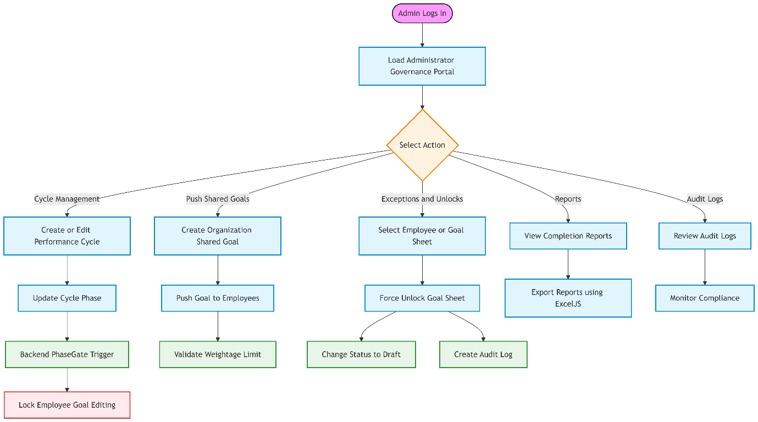
System Administrator Workflow
The System Administrator module in the GoalQuest Performance Management System provides centralized governance over the entire performance management lifecycle. Unlike employees and managers, administrators focus on system configuration, performance cycle management, organizational compliance, reporting, and exception handling.
The workflow is implemented through the Administrator Governance Dashboard, which enables administrators to configure organization-wide settings and oversee the performance management process.

1. Initialization and Dashboard Overview
The workflow begins when a System Administrator successfully logs into the GoalQuest portal.
After authentication, the administrator is redirected to the Administrator Governance Dashboard.
Unlike the Employee and Manager dashboards, this interface focuses on:
- Performance cycle configuration.
- Organizational governance.
- Compliance monitoring.
- System-wide reporting.
- Administrative overrides.
The dashboard serves as the central control panel for managing the organization's performance management process.

2. Phase 1 – Performance Cycle Management
Administrators define and manage the lifecycle of organizational performance cycles.
This functionality is available through the Cycle Management section.
Creating Performance Cycles
The administrator creates new performance cycles for the organization.
Example:
- 2026 Annual Review
Each cycle defines the period during which employees create goals, managers approve them, and performance evaluations are conducted.

Phase Gate Management
Administrators control the active phase of the performance cycle.
Supported phases include:
- GOAL_SETTING
- Q1
- Q2
- Q3
- Q4
When the administrator changes the active phase, the backend applies Phase Gate Middleware to enforce system-wide workflow restrictions.
For example:
- Transitioning from GOAL_SETTING to Q1 automatically:
  - Locks Goal Planning for employees.
  - Prevents further goal modifications.
  - Enables the Monthly/Quarterly Check-In functionality.
This mechanism ensures that all users follow the same organizational performance timeline.

3. Phase 2 – Organization-Wide Goal Distribution
Administrators can assign organization-wide objectives to employees across the system.
This functionality is available through the Push Shared Goals section.
Creating Shared Organizational Goals
The administrator defines common organizational objectives, such as:
- Company-Wide Compliance Certification
- Mandatory Training Completion
- Strategic Business Initiatives
These goals can be distributed to employees throughout the organization.

Intelligent Goal Assignment
Before assigning a shared goal, the backend evaluates each employee's existing goal sheet.
The system calculates:
- Current cumulative goal weightage.
- Remaining available weightage.
The shared goal is assigned only if the employee's total goal weightage remains within the permitted limit.
Weightage Validation
The backend enforces the following rule:
- Total Goal Weightage ≤ 100%
  - Shared goal is successfully assigned.
- Total Goal Weightage > 100%
  - Goal assignment is skipped.
This validation prevents employee over-allocation while maintaining consistency across the organization.

4. Phase 3 – Administrative Exceptions and Overrides
Administrators possess elevated privileges that allow them to override normal system restrictions when necessary.
This functionality is available through the Exceptions & Unlocks section.
Goal Sheet Unlocking
Normally, employees cannot modify Goal Sheets that are in:
- APPROVED
- LOCKED
states.
However, administrators can forcibly unlock a Goal Sheet when exceptional situations arise, such as:
- Incorrect goal configuration.
- Employee department transfer.
- Organizational restructuring.
- Administrative correction requests.
The unlock operation changes the Goal Sheet status back to:
DRAFT
allowing employees to modify and resubmit their goals.

Administrative Audit Trail
Every administrative override is automatically recorded by the backend.
The audit information includes:
- Administrator identity.
- Timestamp of the action.
- Type of override performed.
- Target Goal Sheet.
This audit trail ensures accountability and supports organizational compliance requirements.

5. Phase 4 – Monitoring, Reporting, and Compliance
Administrators monitor organization-wide performance and generate reports for Human Resources and executive leadership.
This functionality is available through the Completion & Stats and Audit Logs sections.
Organization-Wide Progress Monitoring
Administrators can monitor:
- Goal Sheet completion rates.
- Quarterly check-in completion.
- Department-wise progress.
- Overall organizational participation.
These metrics help identify departments or teams that require additional follow-up.

Report Generation
The system supports exporting organizational performance reports using the backend ExcelJS utility.
Reports may include:
- Goal completion statistics.
- Employee participation.
- Department-wise summaries.
- Performance cycle progress.
These reports assist HR and executive management in organizational performance reviews.

Audit Log Review
Administrators can review immutable audit logs that capture significant system events.
Examples include:
- Goal Sheet approvals by managers.
- Administrative overrides.
- Goal Sheet unlock operations.
- Critical workflow transitions.
Each audit record includes:
- User ID
- Timestamp
- Action performed
- Associated system event
These logs provide complete traceability and ensure that the platform remains compliant with organizational governance and auditing requirements.

6. System Administrator Lifecycle
The complete administrator workflow follows the sequence below:
- Administrator logs into the GoalQuest portal.
- The Administrator Governance Dashboard loads with system-wide management and reporting capabilities.
- The administrator creates and manages organizational performance cycles.
- Performance phases are updated (e.g., GOAL_SETTING, Q1, Q2, Q3, Q4), triggering backend phase-gate rules that control user permissions.
- Organization-wide goals are created and distributed while ensuring that employee goal weightage does not exceed 100%.
- Administrators perform exception handling by unlocking Goal Sheets and overriding workflow restrictions when necessary.
- Every administrative override is automatically recorded for auditing and compliance purposes.
- The administrator monitors organizational progress, generates reports using ExcelJS, and reviews audit logs to ensure transparency, compliance, and effective governance throughout the performance management cycle.
This centralized administrative workflow ensures consistent performance cycle management, controlled system access, organizational compliance, comprehensive reporting, and complete auditability across the GoalQuest Performance Management System.

